**Batch: B2 Roll No.: 16010121110**

**Experiment / assignment / tutorial No._______**

**Grade: AA / AB / BB / BC / CC / CD /DD**

**Signature of the Staff In-charge with date**

**Experiment No. 1**

|  |
| --- |
| **TITLE:**  Study of Networking devices (Hub, router, Gateway, Switch etc.) and Transmission Media |

**___________________________________________________________________________**

**AIM:** To study different Networking devices and transmission media used in day to day networks.

**_________________________________________________________________________­­**

**Expected Outcome of Experiment:**

**CO: 1**

**___________________________________________________________________________**

**Books/ Journals/ Websites referred:**

1. A. S. Tanenbaum, “Computer Networks”, Pearson Education, Fourth Edition
2. B. A. Forouzan, “Data Communications and Networking”, TMH, Fourth Edition

___________________________________________________________________________

**Pre Lab/ Prior Concepts:** Basics of LAN and Connecting devices

**___________________________________________________________________________**

**New Concepts to be learned:** Layer wise connecting devices

**___________________________________________________________________________**

**Stepwise-Procedure:**

.

**Study of Connecting Devices**

**Attached in separate document.**

**Study of Transmission Media**

The below information is given for reference purpose only; you need to replace this with the information you have searched

**1. Twisted pair cable**

In balanced pair operation, the two wires carry equal and opposite signals and the destination detects the difference between the two. This is known as differential mode transmission. Noise sources introduce signals into the wires by coupling of electric or magnetic fields and tend to couple to both wires equally. The noise thus produces a common-mode signal which is cancelled at the receiver when the difference signal is taken.

This method starts to fail when the noise source is close to the signal wires; the closer wire will couple with the noise more strongly and the common-mode rejection of the receiver will fail to eliminate it. This problem is especially apparent in telecommunication cables where pairs in the same cable lie next to each other for many miles. One pair can induce crosstalk in another and it is additive along the length of the cable. Twisting the pairs counters this effect as on each half twist the wire nearest to the noise-source is exchanged.

Provided the interfering source remains uniform or nearly so, over the distance of a single twist, the induced noise will remain common-mode. Differential signalling also reduces electromagnetic radiation from the cable, along with the associated attenuation allowing for greater distance between exchanges.

The twist rate (also called pitch of the twist, usually defined in twists per meter) makes up part of the specification for a given type of cable. Where nearby pairs have equal twist rates, the same conductors of the different pairs may repeatedly lie next to each other, partially undoing the benefits of differential mode. For this reason it is commonly specified that, at least for cables containing small numbers of pairs, the twist rates must differ.[

UTP cables are found in many Ethernet networks and telephone systems. For indoor telephone applications, UTP is often grouped into sets of 25 pairs according to a standard 25-pair color code originally developed by AT&T Corporation. A typical subset of these colors (white/blue, blue/white, white/orange, orange/white) shows up in most UTP cables. The cables are typically made with copper wires measured at 22 or 24 American Wire Gauge (AWG),[3] with the colored insulation typically made from an insulator such as polyurethane and the total package covered in a polyurethane jacket.

For urban outdoor telephone cables containing hundreds or thousands of pairs, the cable is divided into smaller but identical bundles. Each bundle consists of twisted pairs that have different twist rates. The bundles are in turn twisted together to make up the cable. Pairs having the same twist rate within the cable can still experience some degree of crosstalk. Wire pairs are selected carefully to minimize crosstalk within a large cable.

Unshielded twisted pair cable with different twist rates

UTP cable is also the most common cable used in computer networking. Modern Ethernet, the most common data networking standard, can use UTP cables. Twisted pair cabling is often used in data networks for short and medium length connections because of its relatively lower costs compared to optical fiber and coaxial cable.

UTP is also finding increasing use in video applications, primarily in security cameras. Many cameras include a UTP output with screw terminals; UTP cable bandwidth has improved to match the baseband of television signals. As UTP is a balanced transmission line, a balun is needed to connect to unbalanced equipment, for example any using BNC connectors and designed for coaxial cable.

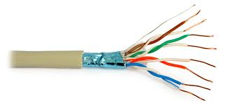

Fig 7.Twisted Pair Cable

**2. Coaxial cable**

Coaxial cable is the kind of copper cable used by cable TV companies between the community antenna and user homes and businesses. Coaxial cable is sometimes used by telephone companies from their central office to the telephone poles near users. It is also widely installed for use in business and corporation Ethernet and other types of local area network.

Coaxial cable is called "coaxial" because it includes one physicalchannel that carries the signal surrounded (after a layer of insulation) by another concentric physical channel, both running along the same axis. The outer channel serves as a ground. Many of these cables or pairs of coaxial tubes can be placed in a single outer sheathing and, with repeaters, can carry information for a great distance.

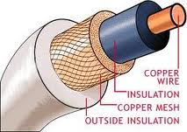

Fig 8.Coaxial Cable

**Optical Fiber**

Fiber-optic communication is a method of transmitting information from one place to another by sending pulses of light through an optical fiber. The light forms an electromagnetic carrier wave that is modulated to carry information. First developed in the 1970s, fiber-optic communication systems have revolutionized the telecommunications industry and have played a major role in the advent of the Information Age. Because of its advantages over electrical transmission, optical fibers have largely replaced copper wire communications in core networks in the developed world.

The process of communicating using fiber-optics involves the following basic steps: Creating the optical signal involving the use of a transmitter, relaying the signal along the fiber, ensuring that the signal does not become too distorted or weak, receiving the optical signal, and converting it into an electrical signal.

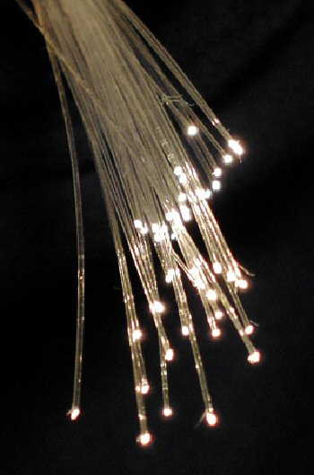

Fig 9.Fiber Optics Cable

**Summary**

The features of the connecting devices and transmission media can be explained in brief as follows:

Every connection device is present in a osi layer. It acts as an medium or device limited to that layer only.

**CONCLUSION:**

**Thus we have understood how various networking devices and mediums work. We studied various devices and their position in OSI models.**

**Post Lab Questions**

1. Compare Hub, switch, bridge, and gateway and specify the use in different cases.

The key difference between hubs, switches and bridges is that hubs operate at Layer 1 of the OSI model, while bridges and switches work with MAC addresses at Layer 2. Hubs broadcast incoming traffic on all ports, whereas bridges and switches only route traffic towards their addressed destinations. A gateway, as the name suggests, is a passage to connect two networks that may work upon different networking models. They work as messenger agents that take data from one system, interpret it, and transfer it to another system. Gateways are also called protocol converters and can operate at any network layer. Gateways are generally more complex than switches or routers. A gateway is also called a protocol converter. Their use depends on the functionality of OSI layer

1. Which of the following device is used to connect two systems, especially if the systems use different protocols?

A.hub

B.bridge

C.gateway

D.repeater

E.None of the above

C

1. Frames from one LAN can be transmitted to another LAN via the device

A. Router

B. Bridge

C. Repeater

D. Modem

B